Project Charter
Date

Project Title: Property Management
Project Start Date: 05/11/2021 Projected Finish Date: 06/02/2021
Budget Information:
The project cost around 15,000 dollars for completion.
Project Manager:
Name : Jahna Sri Aneela Ankam
Phone : 660-528-1262
E-mail : S541988@nwmissouri.edu
Project Objectives:
To create a website which gives the information about the properties that are available for sale.
Success Criteria:
Finishing the project on time and making sure it's online, error-free, and has a responsive and user-friendly GUI.
Approach:
For this project, we'll take an agile approach. We'll meet with the client once a week to discuss the project's progress. Client specifications will be gathered, and necessary action will be taken. We will not let anyone or something down in this project as a team. Every member of the team is supportive of the others. Since we have other representatives to cover our individual flaws, they are not apparent. We'll have regular meetings via Zoom to keep track of the project's progress and to assist one another if someone falls behind. We'll use Northwest Email and Skype for Business to communicate and hold fast online meetings.
Roles and Responsibilities
Name and Signature | Role | Position | Contact Information
Jahna Sri Aneela Ankam  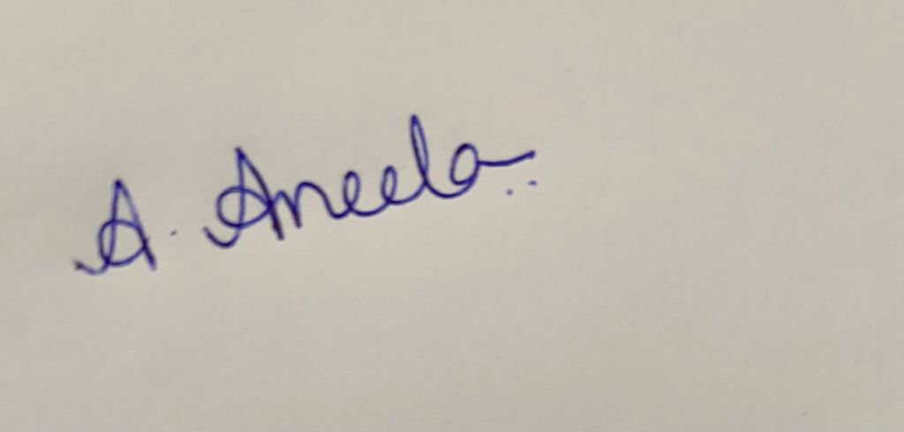 | Project Manager/Web application Developer | Developer | S541988@nwmissouri.edu
Saisumithra Jagarlamudi  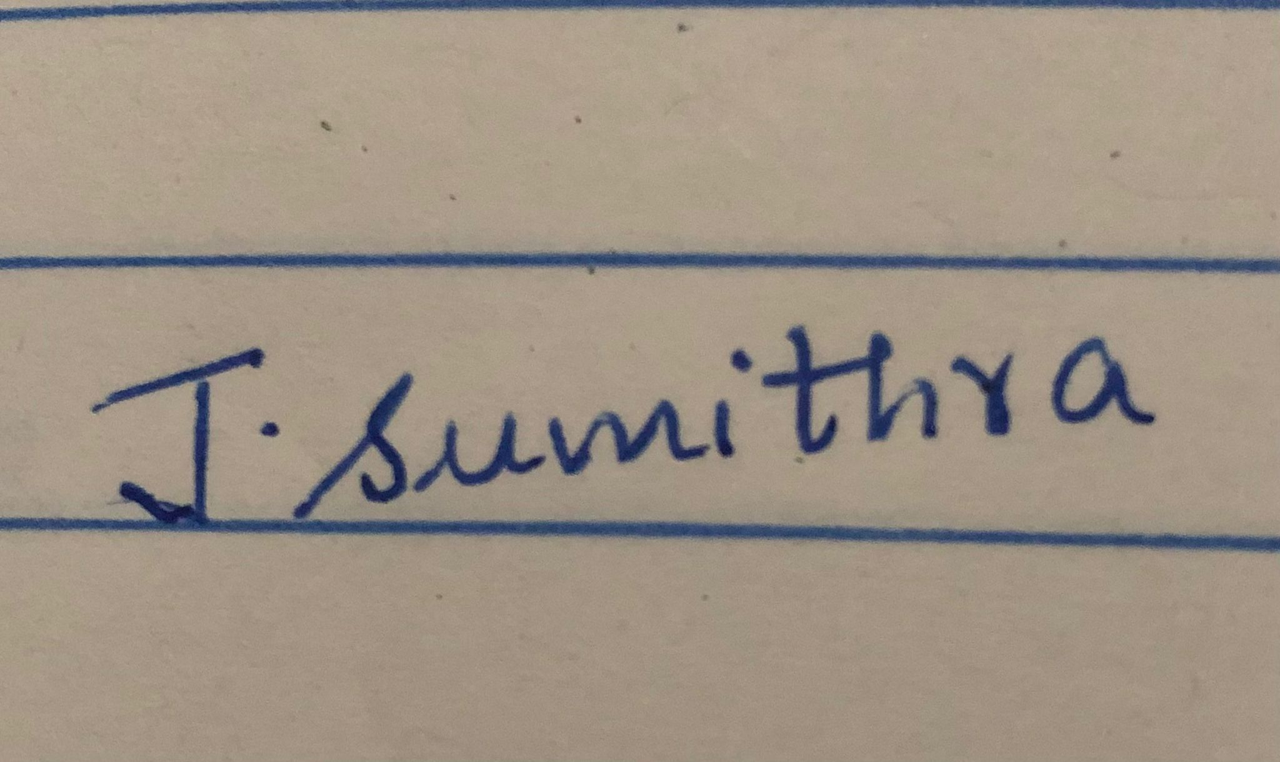 | Team lead/ Backend developer | Developer | S542361@nwmissouri.edu
Sowmya Yalamarthi  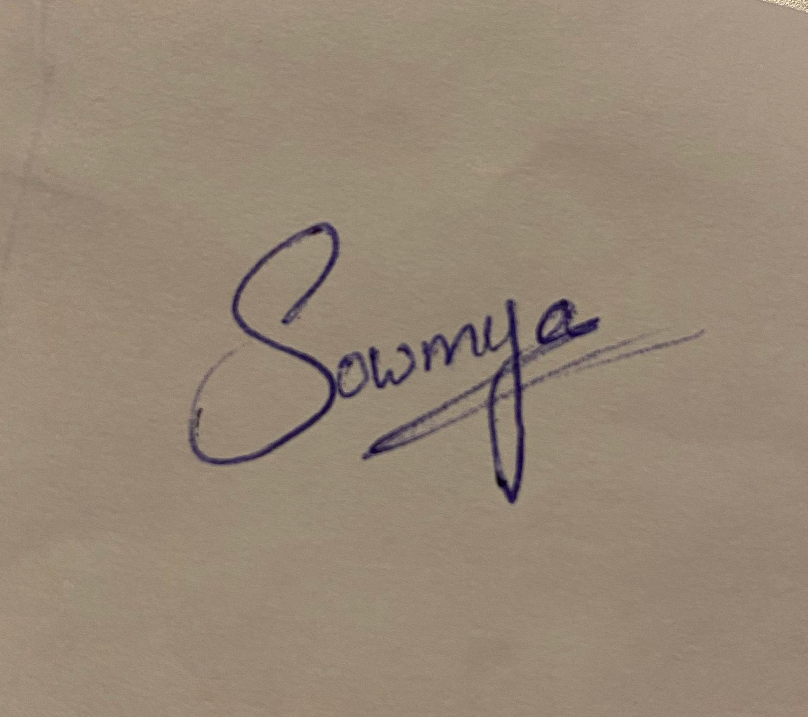 | UI Developer | Developer | S542049@nwmissouri.edu
Padmini Duggirala  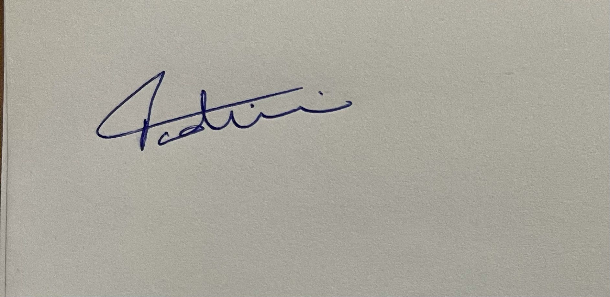 | Testing Manager | Tester | S542358@nwmissouri.edu
Manisha Mandapati  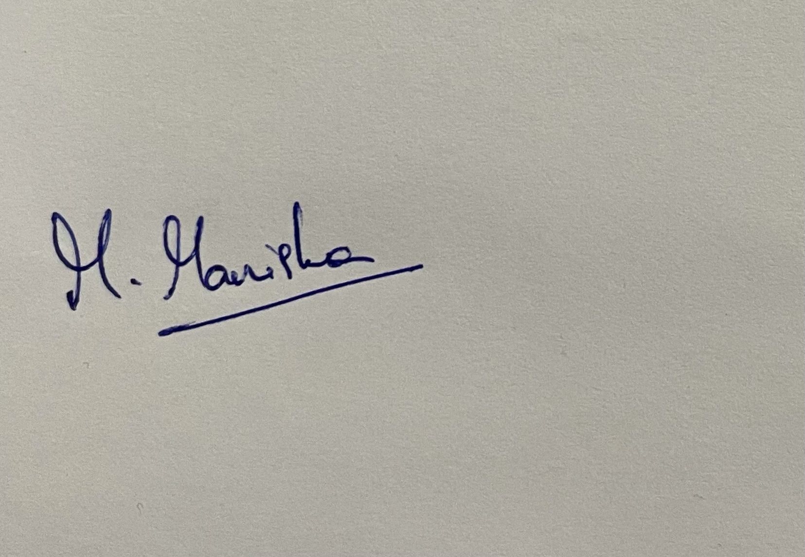 | Scrum Master | Scrum Master | S542043@nwmissouri.edu
Comments: (Handwritten or typed comments from above stakeholders, if applicable)

